  DEPARTMENT OF TELUGU

Co-Curricular & Extracurricular Activities

                                                     2016-17

|  |  |  |  |  |
| --- | --- | --- | --- | --- |
| S.No | Date | Nature of Activity | Title of the Activity | Details of Resource Persons ( Name, Designation etc., ) |
| 1 | 06-04-2017 | Ashtavadanam | Ashtavadanam | Sri.M.Srinivasarao |
| 2 | 29-08-2017 | Gidugu Jayanthi | Extension Lecture | Prof. K.P.Subbarao  Andhra University |
| 3 | 21-09-2017 | Gurajada Jayanthi | Extension Lecture |  |

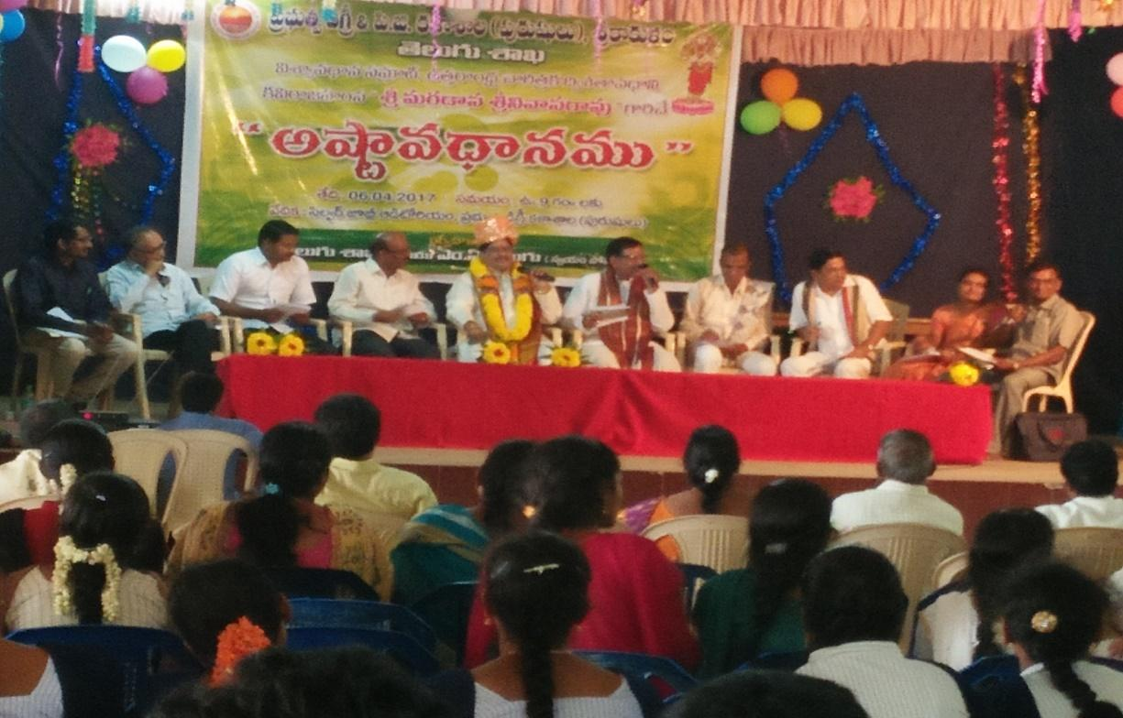

ASHTAAVADHAANAM

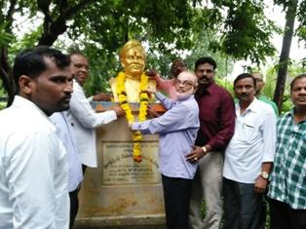

GIDUGU RAMAMURTY JAYANTHI-Prof.K.P.Subbarao

                                                       2017-18

|  |  |  |  |  |
| --- | --- | --- | --- | --- |
| S.No | Date | Nature of Activity | Title of the Activity | Details of Resource Persons ( Name, Designation etc., ) |
| 1 | 29-08-2018 | Gidugu Jayanthi | Extension Lecture | Prof. K.Ramji,Vice-Chancellor,  Dr.B.R.Ambedkar University |
| 2 | 21-09-2018 | Gurajada Jayanthi | Extension Lecture | Attada Appalnaidu, Famous Writer |

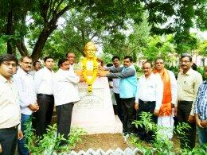

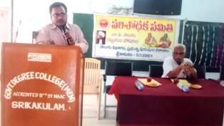

Gurajada Jayanthi-Attada Appalnaidu

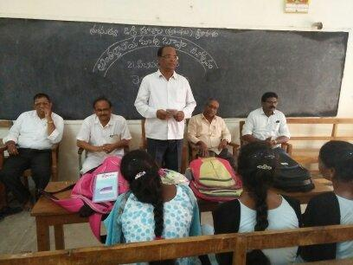

International Mother Tonge Day-Dr.M.Baburao

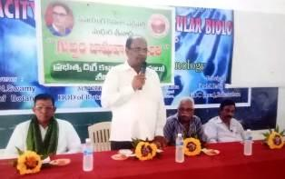

Gurram Jashuva Jayanthi-Vidwan P.Haranadharao

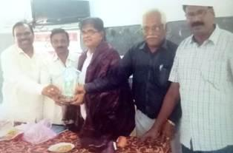

Gurajada Jayanthi-Dr.Dusi.Dharamarao(INTAACH President)

                                                      2018-19

|  |  |  |  |  |
| --- | --- | --- | --- | --- |
| S.No | Date | Nature of Activity | Title of the Activity | Details of Resource Persons ( Name, Designation etc., ) |
| 1 | 29-08-2019 | Gidugu Jayanthi | Extension Lecture | Prof. K.Ramji,Vice-Chancellor,  Dr.B.R.Ambedkar University |
| 2 | 21-09-2019 | Gurajada Jayanthi | Extension Lecture | Attada Appalnaidu, Famous Writer |
| 3 | 28-09-2019 | Jashuva jayanthi | Extension lecturer | Dr. Guruguballi Srirama Murthy lecturer |



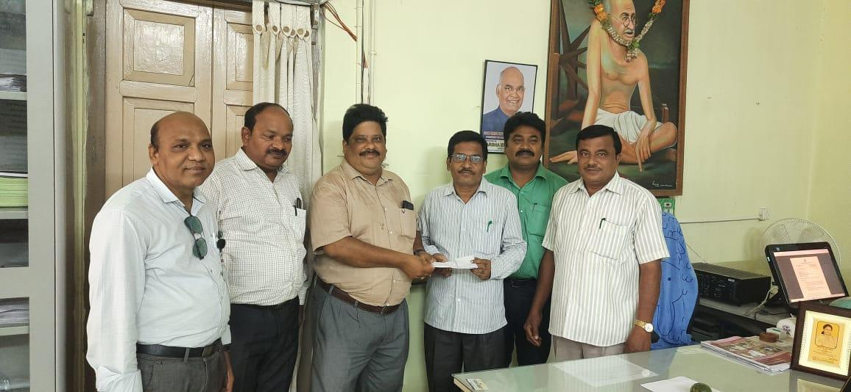

                                                    2019-20

|  |  |  |  |  |
| --- | --- | --- | --- | --- |
| S.No | Date | Nature of Activity | Title of the Activity | Details of Resource Persons ( Name, Designation etc., ) |
| 1 | 29-08-2020 | Gidugu Jayanthi | Extension Lecture | Prof. K.Ramji,Vice-Chancellor,  Dr.B.R.Ambedkar University |
| 2 | 21-09-2020 | Gurajada Jayanthi | Extension Lecture | Attada Appalnaidu, Famous Writer |
| 3 | 28-09-2020 | Jashuva jayanthi | Extension lecturer | Dr. Guruguballi Srirama Murthy lecturer |

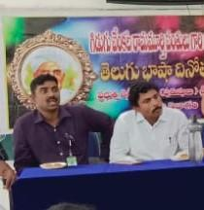

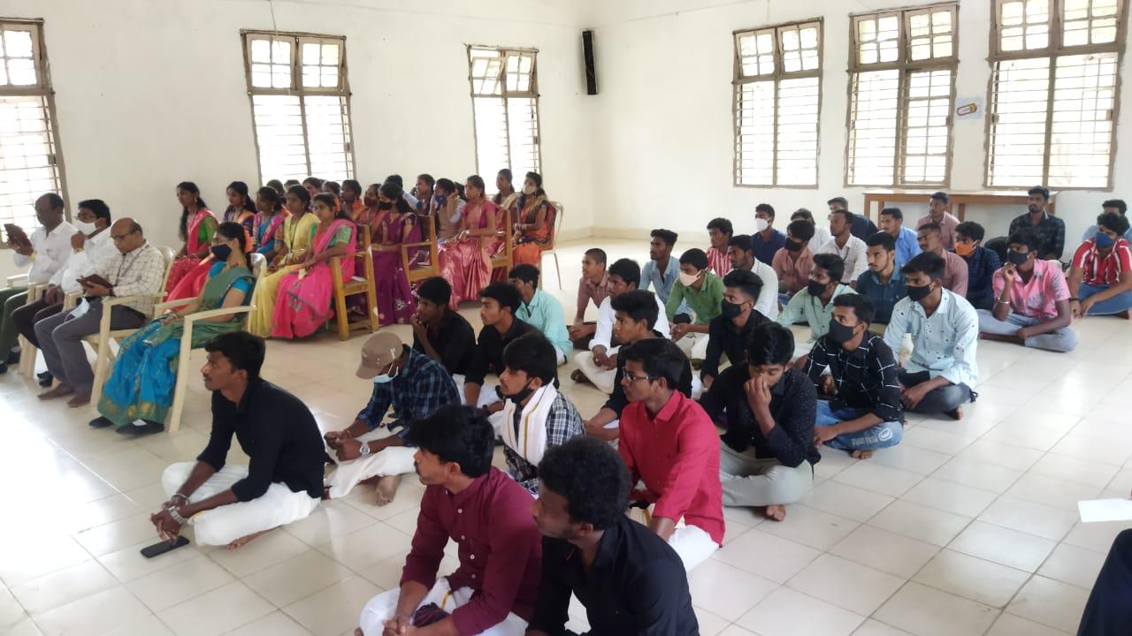

                                                            2020-21

|  |  |  |  |  |  |
| --- | --- | --- | --- | --- | --- |
| S.No | Date | Nature of Activity | Title of the Activity | Details of Resource Persons ( Name, Designation etc., ) | |
| 1 | 13,14-May, 2021 | International Webinar | Kalipatnam Ramarao-Sahityam- Samalochana | Professor velamala simmanna,,  Attada Appalanaidu,  Ganteda Gowrinaidu,  Thota Kuura Prasad,  Mangipudi Radhika |  |
| 2 | 29-08-2021 | Gidugu Jayanthi | Extension Lecturer | Principal, Government Degree College Men, Srikakulam | |
| 3 | 21-09-2021 | Gurajada  Jayanthi | Extension Lecturer | Principal, Government Degree College Men, Srikakulam | |
| 4 | 28-09-2021 | Jashuva  Jayanthi | Extension Lecturer | Principal, Government Degree College Men, Srikakulam | |

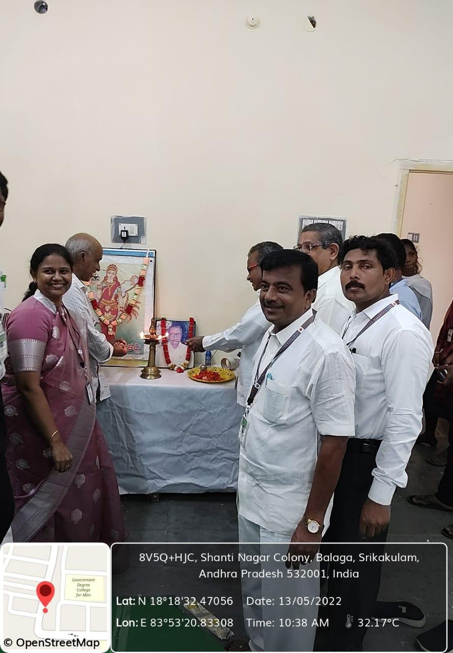

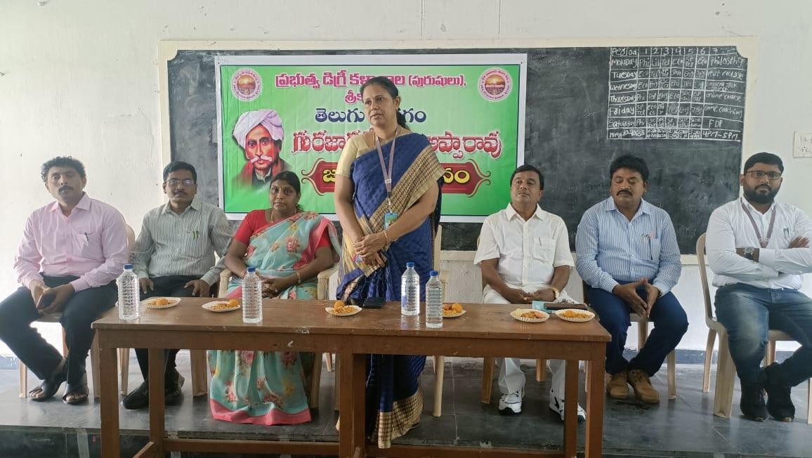

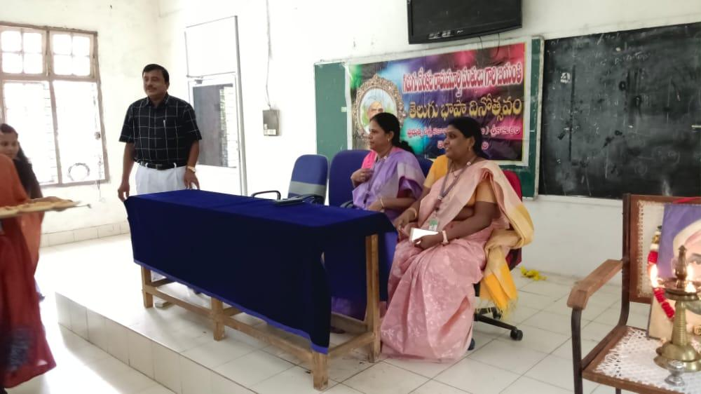

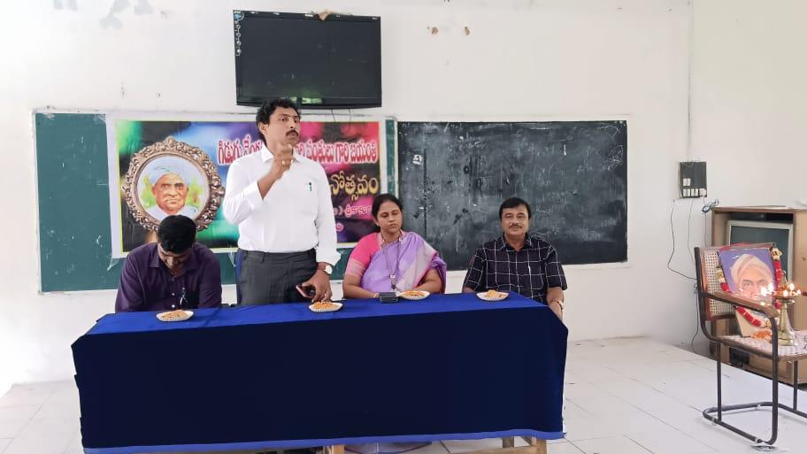

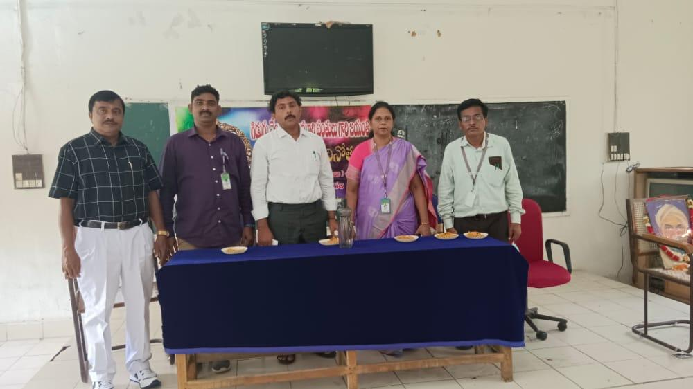

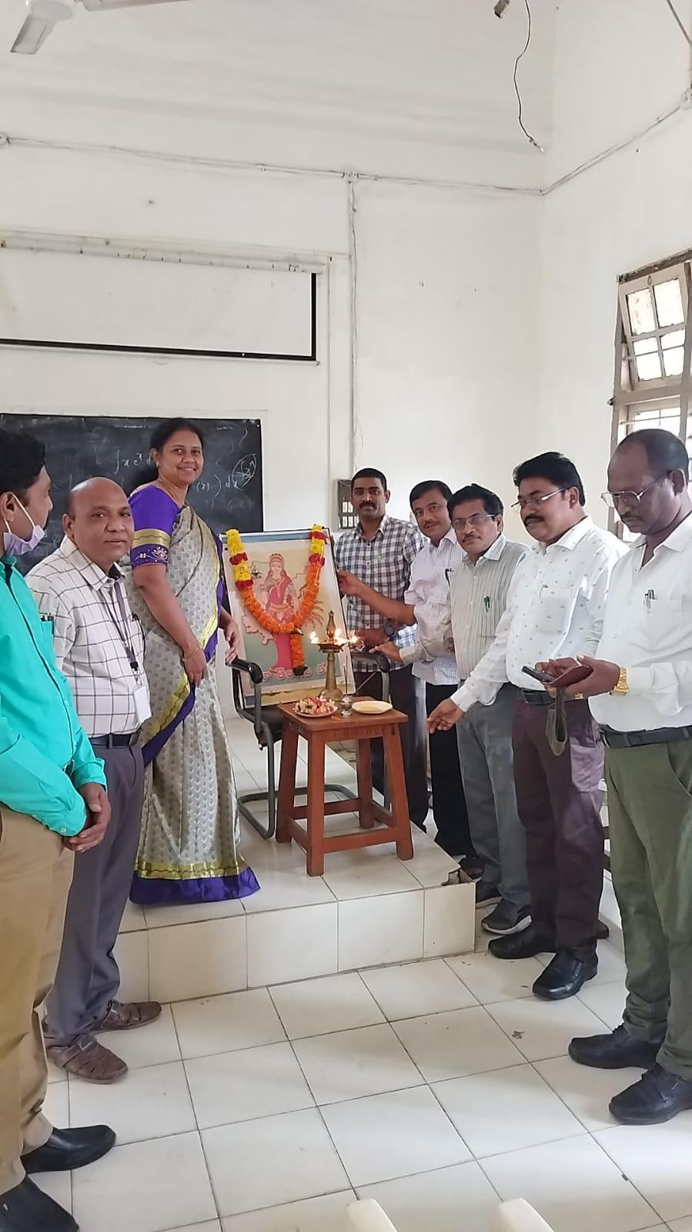

                                                                        2021-22

|  |  |  |  |  |
| --- | --- | --- | --- | --- |
| S.No | Date | Nature of Activity | Title of the Activity | Details of Resource Persons ( Name, Designation etc., ) |
| 1 | 29-08-2022 | Gidugu Jayanthi | Extension Lecture | Dr.P.Surekha(Principal) |
| 2 | 21-09-2022 | Gurajada Jayanthi | Extension Lecture | Principal, Government Degree College Men, Srikakulam |
| 3 | 28-09-2022 | Jashuva jayanthi | Extension lecturer | Principal, Government Degree College Men, Srikakulam |

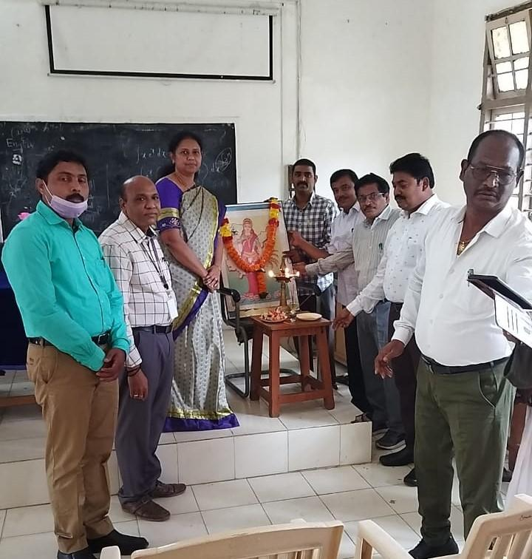

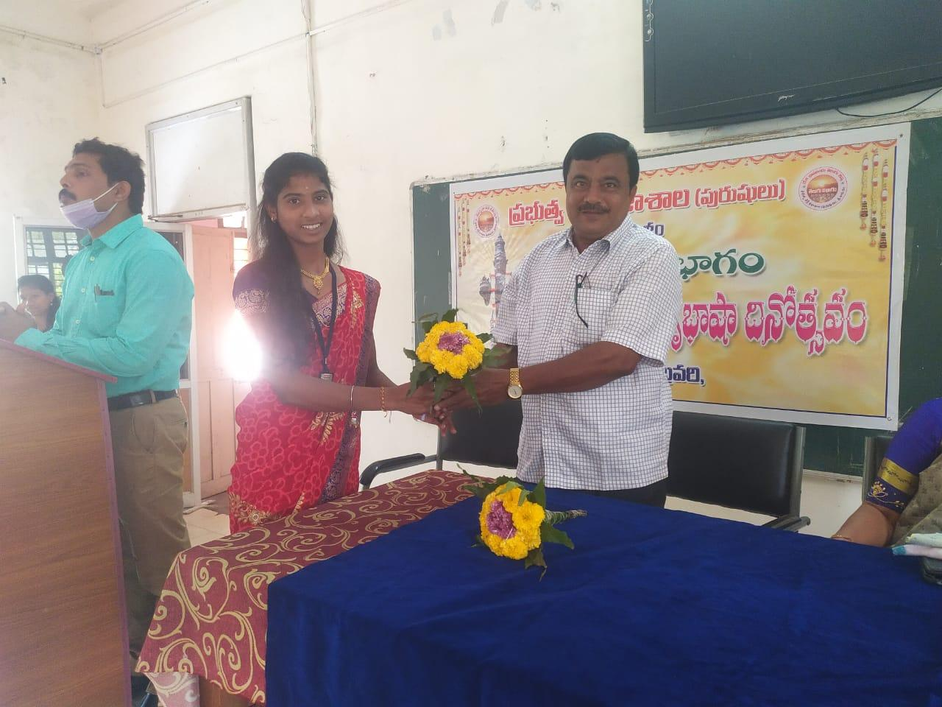



              Dussera Sambaraalu [2022]

