# 

# DEPARTMET OF ECONOMICS

***ACTIVITIES - 2023-2024***

## GOVERNMENT DEGREE COLLEGE (MEN), SRIKAKULAM

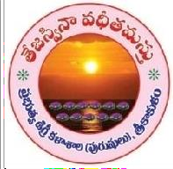

***Invitation***

Date: **11-07-2023** Time: **10.30 AM**

**Venue: New Block**

# Department Of Economics

***Cordially invite you to the***

***“WORLD POPULATION DAY – 2023”***

Celebrations

### President: Dr. P.Surekha, M.Sc., Ph.D

Principal, GDC-Men, Srikakulam

### Chief Guest: Smt.K.Sudha

District Employment Officer, Srikakulam

**Special Invitees: 1. Sri. S. Satyanarayana,** Vice-Principal

**2. Dr. Haritha,** IQAC-Coordinator

**Convener: Sri. Ch. Rama Murty,** Lecturer in-charge

**Organizing Secretary: Dr.D.Pyditalli,** Lecturer in Economics

**\*\*\***

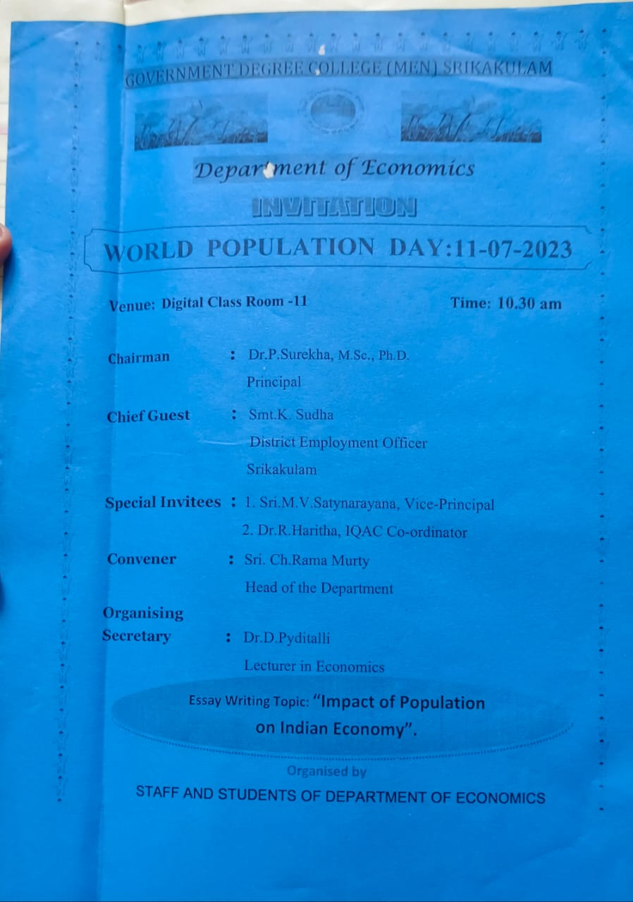

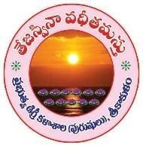

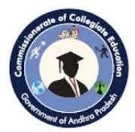**GOVERNMENT DEGREE COLLEGE MEN), SRIKAKULAM EVENT ORGANIZED REPORT**

**(2023-2024)**

|  |  |
| --- | --- |
| **Name of Department** | ECONOMICS |
| **Name of Event Organized** | World Population Day |
| **Title of the Event** | World Population Day - 2023 |
| **Date of Event Organized** | **11-07-2023** |
| **Name of the coordinator of the Event** | Ch.Ramamurty |
| **No. of Participant (Student +Staff)** | 70 |
| **Name of the Expert with designation** | Smt.K.Sudha District Employment Officer, Srikakulam |
| **Contact number & Address of the Expert** | 7396219578  Srikakulam |
| **Objective of the Event** | To create awareness on population among the students and public.  To understand and application of the population dividend |
| **Description of the event** | World Population Day is celebrated annually on 11 July to focus attention on the urgency and importance of population issues.  The Day was established by the then- Governing Council of the UN Development Programme in 1989, an outgrowth of the interest generated by the Day of Five Billion, which was observed on 11 July 1987. By resolution 45/216 of December 1990, the UN General Assembly decided to continue observing World Population Day to enhance awareness of population issues, including their relations to the environment and development. The Day was first marked on 11 July 1990 in more than 90 countries.  **2023 theme is "A world of 8 billion: Towards a resilient future for all -**  **harnessing opportunities and ensuring rights** |

|  |  |
| --- | --- |
|  | **and choices for all". This year's theme aims to promote a flexible and sustainable future** |
| **Outcome of the Event** | Students acts towards Human Resource Development and population control |

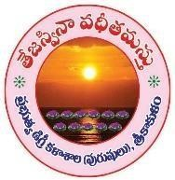**GOVERNMENT DEGREE COLLEGE MEN), SRIKAKULAM EVENT PHOTO GALLERY**

**(2022-2023)**

**Govt. Degree College (Men), Srikakulam Department of Economics**

**11-07-2023**

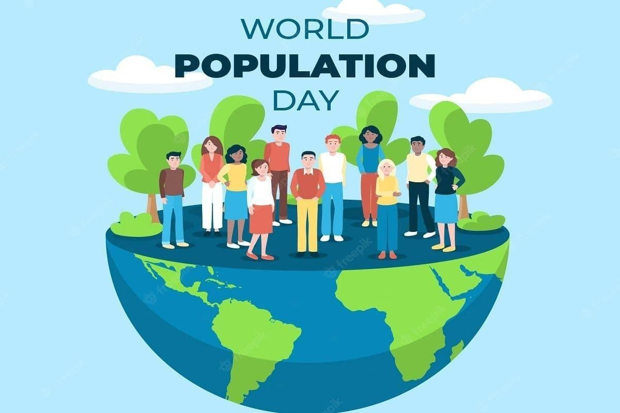

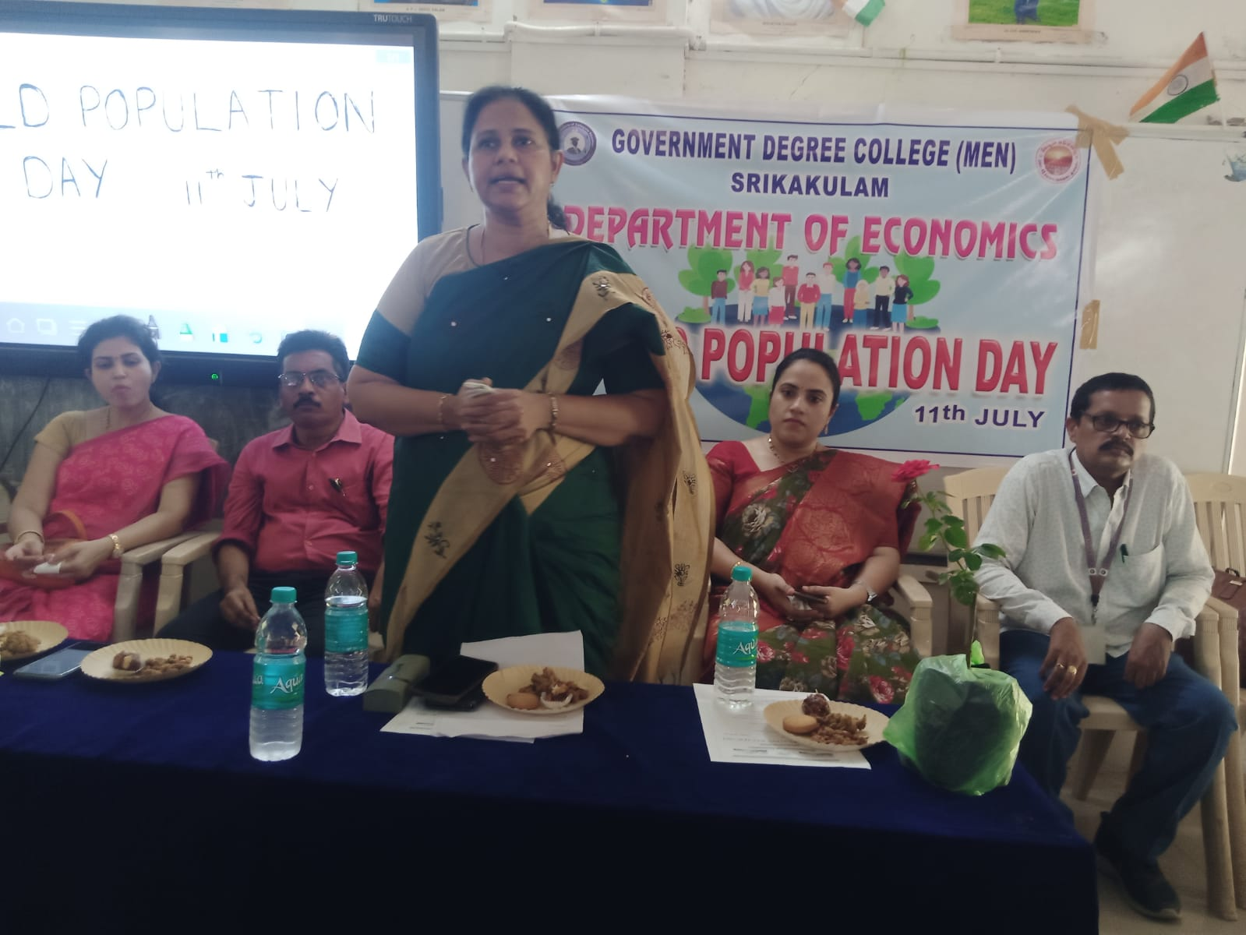

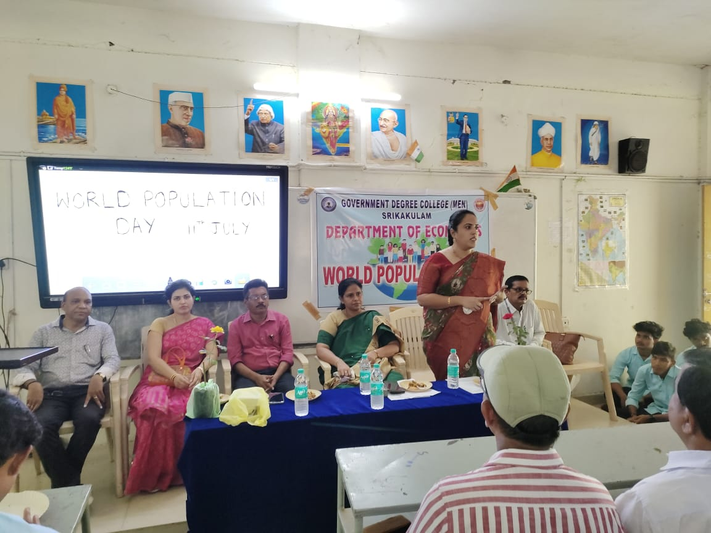

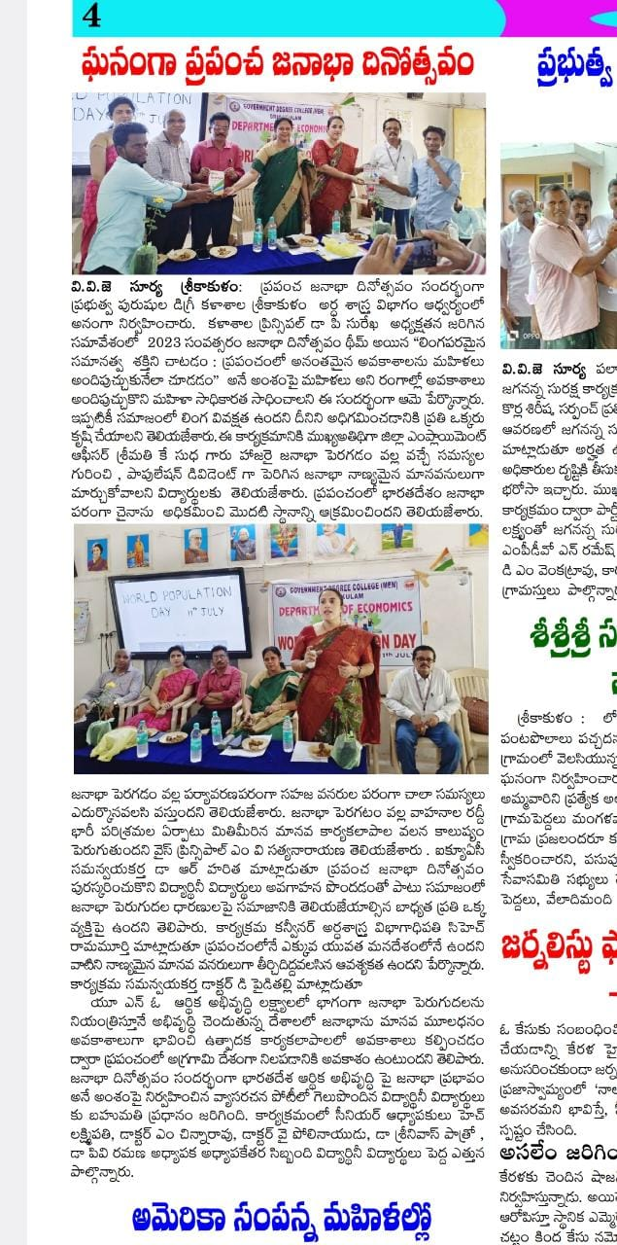

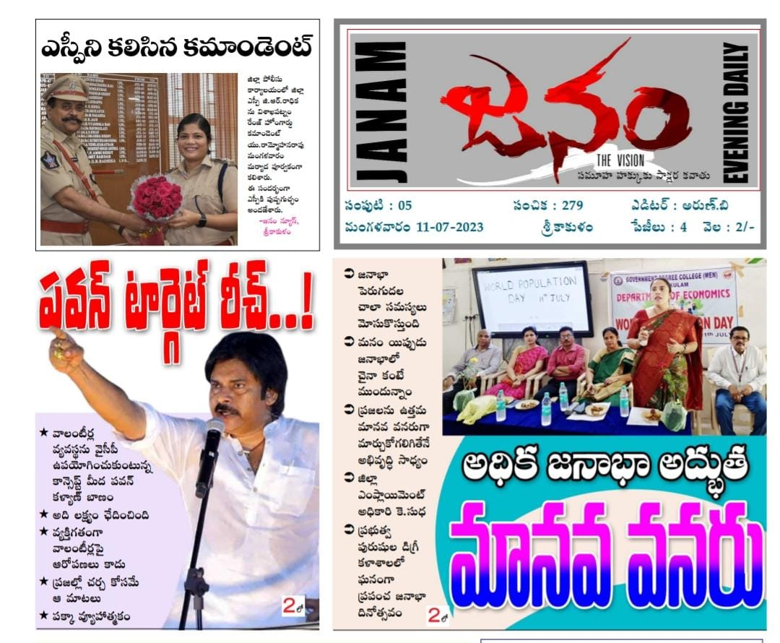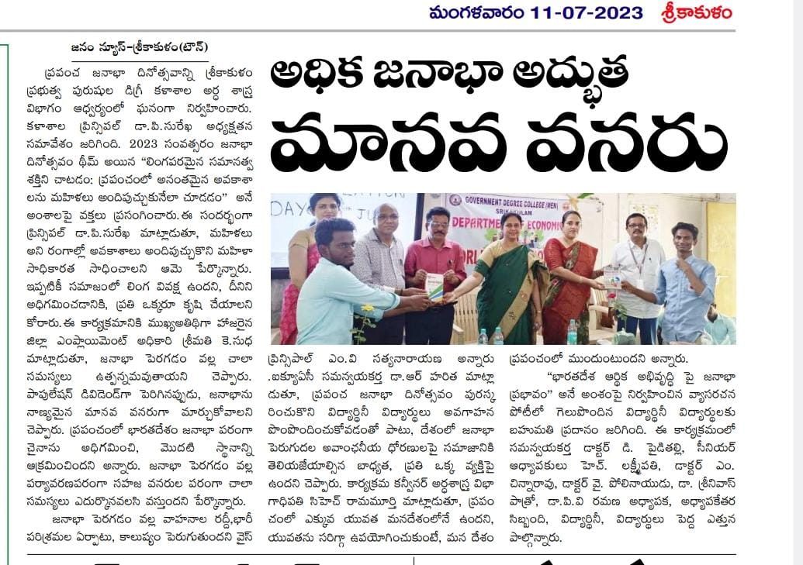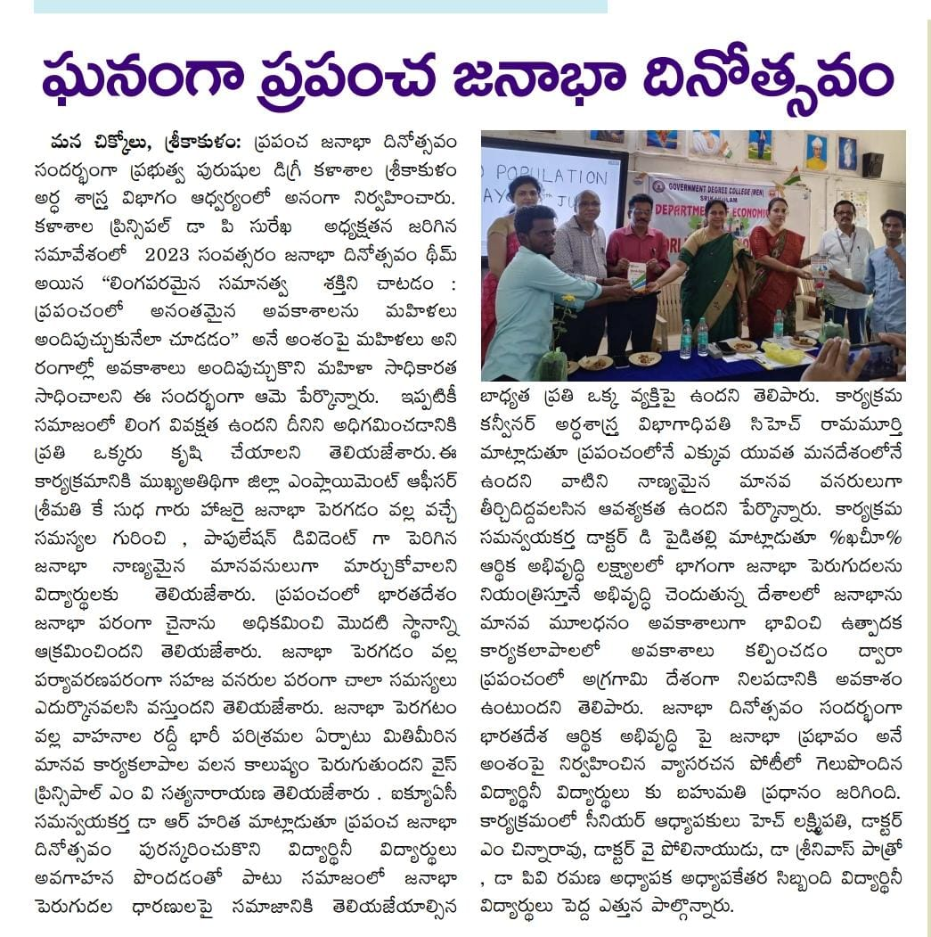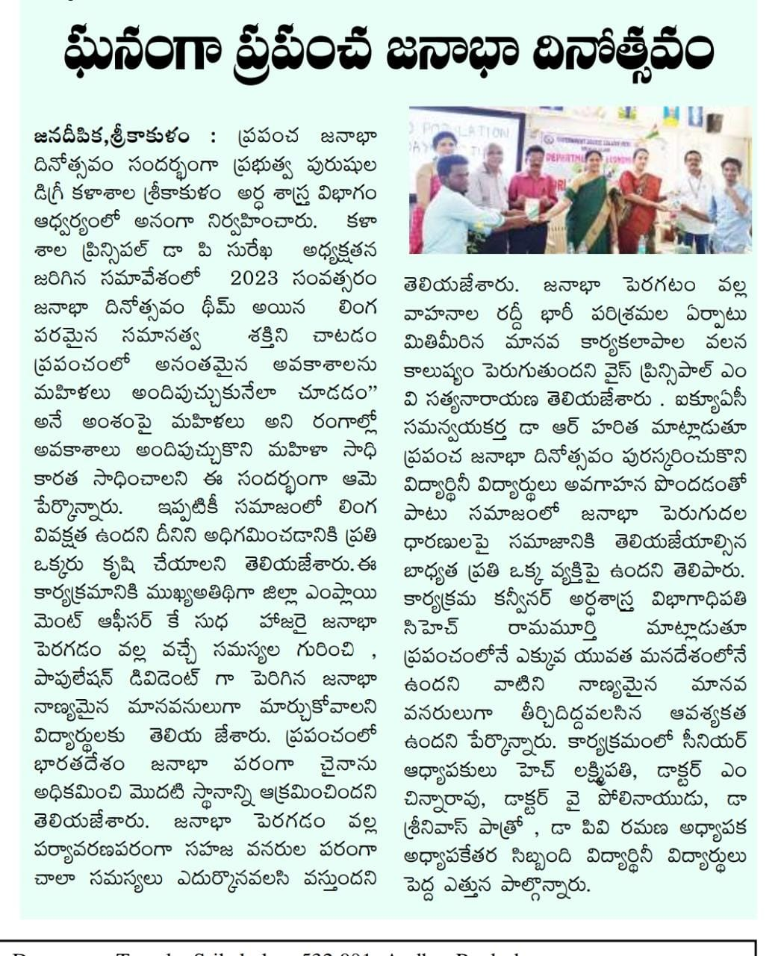

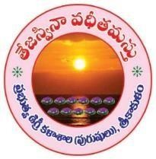**OVERNMENT DEGREE COLLEGE MEN), SRIKAKULAM EVENT FEEDBACK REPORT**

**(2023-2024)**

|  |  |
| --- | --- |
| Name of the event | WORLD POPULATION DAY 2023 |
| Department | ECONOMICS |
| Date | 11-07-2023 |
| Name of student | B.Srinu |
| Class | 3rd BA (HEP) |
| Mobile no. | 7608509191 |

1. Did the event fulfil it’s objectives?
   * Yes/ No
2. How useful was the event for you? (0 being Not useful and 5 Most useful)

|  |  |  |  |  |  |
| --- | --- | --- | --- | --- | --- |
| 0 | 1 | 2 | 3 | 4 | * 5 |

1. Rate the overall success of the event (0 being Not useful and 5 Most useful)

|  |  |  |  |  |  |
| --- | --- | --- | --- | --- | --- |
| 0 | 1 | 2 | 3 | 4 | * 5 |

1. List the key takeaway points from the events.

Population explosion – Demographic Dividend – Human Resource Development Optimum utilization of Resources

1. Suggestions if any No

### GOVERNMENT DEGREE COLLEGE (MEN), SRIKAKULAM

Department of Commerce and Department of Economics

**CONSUMER CLUB**

**INVITATION**

**POSTER PRESENTATION: ON “CONSUMER AWARENESS 2023”**

### DATE: 20-12-2023 TIME: 10-00AM

VENUE: SILVER JUBLEE AUDITORIUM

Instructions:

1. **Students can participate directly**
2. **No registration Fee**
3. **Each group consists maximum 3 members**
4. **1st , 2nd and 3rd Prizes will be announced based on presentation performance**
5. **Judges decision is final**

**PRESIDENT : Dr.P.SUREKHA, M.Sc**

Principal

**CHIEF GUEST: Baratam Sriram Murthy,**

Charted Accounted Srikakulam

**GEST OF HONORS: 1. Sri D.Venkata Ramana**

**District Civil Supply Officer**

* 1. **Sri Bagadi Rammohan Rao**

**President, District Consumer Rights Forum**

**Sri. H.Lakshmipathi Sri Ch.Ramamurthy**

**Convener Co-Convener**

**S.Eswara rao Organizing Secretary**

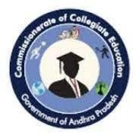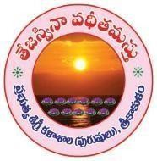GOVERNMENT DEGREE COLLEGE MEN), SRIKAKULAM EVENT ORGANIZED REPORT

(2023 -20 24)

|  |  |
| --- | --- |
| **Name of Department** | Department of Economics |
| **Name of Event Organized** | Consumer’s Day |
| **Title of the Event** | **District level** awareness programme on consumerism |
| **Date of Event Organized** | 20/12/23 |
| **Name of the coordinator of the Event** | Ch.Ramamurty |
| **No. of Participant (Student +Staff)** | 120 |
| **Name of the Expert with designation** | Sri D. Venkataramana Dist. Civil supply officer.  Sri. B Rammohan Rao president Dist Consumer Rights Fourm.  Smt. K.Kalyani Drug Inspector Sri K. Venkatarathnam Asst. Food Controllor.  Sri S. Visweswara rao Asst.Controllor, Legal Meterology |
| **Contact number & Address of the Expert** | Sri D. Venkataramana Dist. Civil supply officer, Srikakulam |
| **Objective of the Event** | To create awareness on consumerism among the students and public.  To know about the rights and responsibilities of the consumers |
| **Description of the event** | Consumer protection act 1986 amended in2019 seeks to promote and protect the interest of consumer against deficiency and defects in goods and services including food medicine etc. It also explain to secure therights of  consumer against unfair or restrictive trade practices |
| **Outcome of the Event** | To know the consumer rights and how to protect from unfair trade practices |

GOVERNMENT DEGREE COLLEGE MEN), SRIKAKULAM

EVENT PHOTO GALLERY (2023 -2024 )

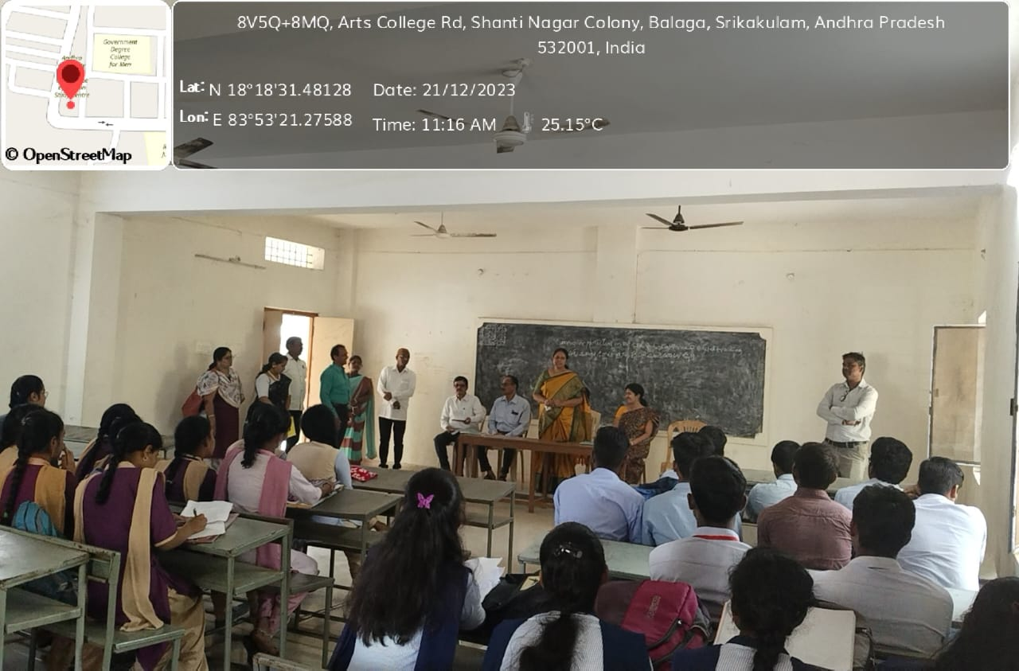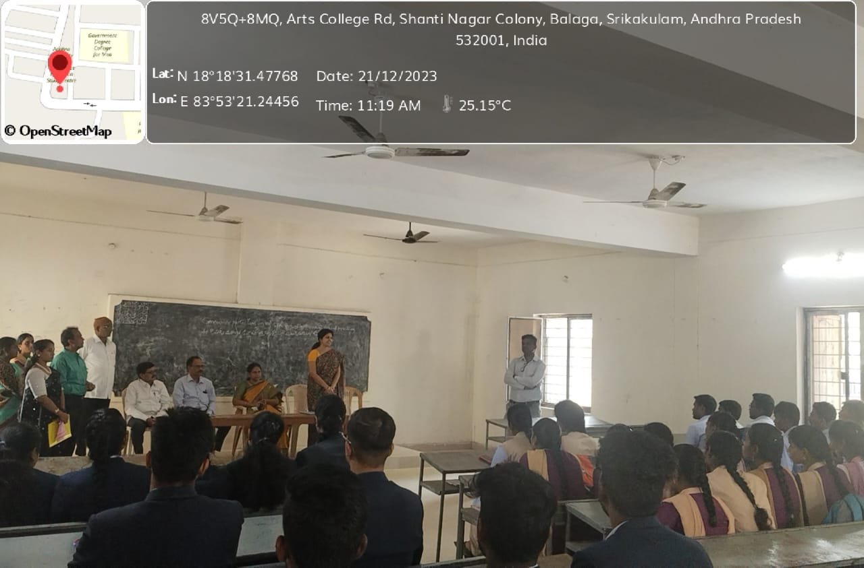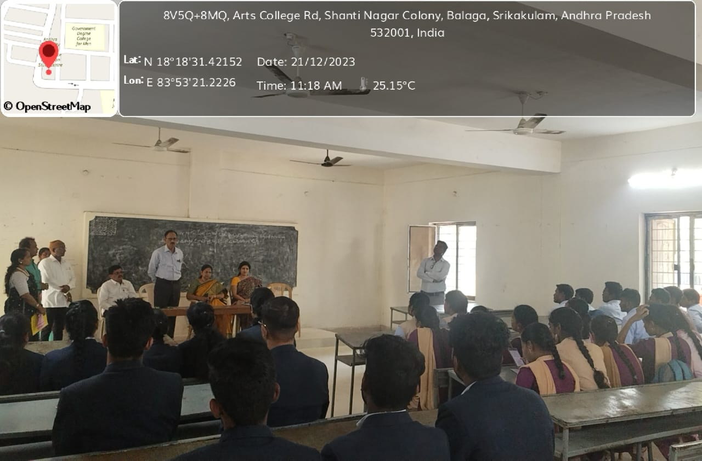

GOVERNMENT DEGREE COLLEGE MEN), SRIKAKULAM

EVENT FEEDBACK REPORT

(2023 -2024 )

|  |  |
| --- | --- |
| Name of the event | District level Awareness Programme on Consumerism |
| Department | Economics |
| Date | 20/12/23 |
| Name of student | S.Prem kumar |
| Class | 2nd BA (HEP) |
| Mobile no. | 9949769356 |

* + 1. Did the event fulfil it’s objectives?

Yes

* + 1. How useful was the event for you? (0 being Not useful and 5 Most useful)

|  |  |  |  |  |  |
| --- | --- | --- | --- | --- | --- |
| 0 | 1 | 2 | 3 | 4 | 5** |

* + 1. Rate the overall success of the event (0 being Not useful and 5 Most useful)

|  |  |  |  |  |  |
| --- | --- | --- | --- | --- | --- |
| 0 | 1 | 2 | 3 | 4 | 5** |

* + 1. List the key takeaway points from the events.
* Students will have a comprehensive understanding about the existing law on

consumerprotection in India.

* + Students will be aware of the basic procedures for handling consumer dispute.
    1. Suggestions if any