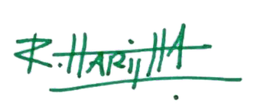

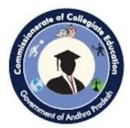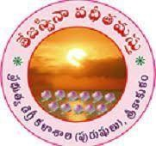

IQACCoordinator





# 2024-25

|  |  |
| --- | --- |
| **NameofDepartment/Cell** | **DEPARTMENTOFECONOMICS** |
| **Nameof EventOrganized** | ***TAXCONSULTANCY*** |
| **TitleoftheEvent** | ***TAXCONSULTANCY*** |
| **Dateof EventOrganized** | ***01-11-2024to17-12-2024*** |
| **Nameof thecoordinatorof theEvent** | **Sri Ch.Ramamurty** |
| **No.of Participant(Student+Staff)** | **20** |
| **Nameof theExpertwithdesignation** | **D SURESH**  **Tax Consultant** |
| **Contactnumber&Address oftheExpert** | **6301353804** |
| **Objectiveof theEvent** | **Understand Basic concepts of the Tax Consultancy.Tocreateinterestamongthestudentstopursuehigher education**  **.** |
| **Descriptionof the event** | **Department Of Economics of Government Degree College(M),Srikakulam.ConductedaCertification Course For the Final Year Students On Tax Consultancy.**  **UnderstandvarioustermsandconceptsofTaxation Draws critical formulas, diagrams and graphs**  **.EnhancetheKnowledgeofFunctioningofTaxation**  **.Enhance the behavioral changes among the students.Criticallyexaminesusingofthedataand figures** |
| **OutcomeoftheEvent** | TheEventSuccessfullyConductedWith30 Students. All the Students Utilized Well. |

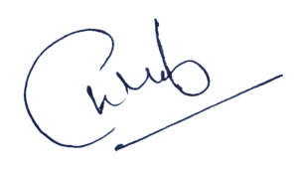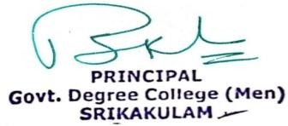

Event Coordinator Principal

## WhatsApp Image 2022-07-18 at 12.55.09 PM.jpegGovernment Degree College (M),Srikakulam

### DEPARTMENT OF ECONOMICS 21-10-2024.

**RESOLUTIONS**

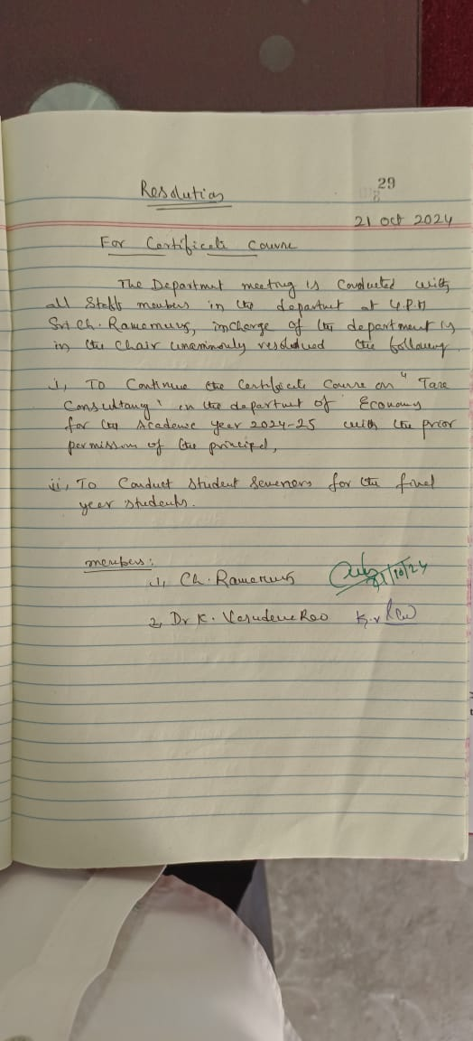

***O/oThe Principal,GovernmentDegree***

***College(M), Srikakulam.***

## Circular

This is to inform all the final year students Department of Economics of our college is going to Conduct Certification Course On Tax Consultancy From *from 01- 11-2024 to 17-12-2024*. So, all the final year Students are informed to Attend and Utilize The Classes.

Principal

Date:21-10-2024

Station: Srikakulam.

**Signatures:**

# Certificate Course on Tax Consultancy

### Academic year 2024-2025

Certificate course on Tax Consultancy organized by the Department of Economics is inaugurated by Principal Dr. P. Surekha , Government Degree College (Men), Srikakulam. In this regard IQAC Co-ordinator explained the importance and future scope of the Certificate Course on Tax Consultancy. Sri Ch.Ramamurty, Lecturer in Economics and course Co-ordinator has explained the Objectives of the Course.

1. Dr.P.Surekha,Principal
2. Dr.R.Haritha,IQACCo-ordinator
3. SriCh.Ramamurty,CourseCo-ordinator

## Objectives

1. **DrawsCriticalTablesformulaeofthedata**
2. **UnderstandBasicconceptsoftheTaxConsultancy**
3. **Tocreateinterestamongthestudentstopursuehighereducation**
4. **Usefultodevelopskillamongthestudents**
5. **TopromoteEmployabilityfacilities**

## LearningOutcomefortheCertificateCourse

1. **UnderstandvarioustermsandconceptsofTaxation**
2. **Drawscriticalformulas,diagramsandgraphs**
3. **EnhancetheKnowledgeofFunctioningofTaxation**
4. **Enhancethebehavioralchangesamongthestudents**
5. **Criticallyexaminesusingofthedataandfigures**

# Syllabus

|  |  |  |
| --- | --- | --- |
| **Lesson** | **Topics** | **Hours** |
| **Lesson- I** | **Taxation–DefinitionclassificationofTaxation** | **3Hours** |
| **Lesson- II** | **DirectTaxandIndirectTaxmeritsanddemerits** | **4Hours** |
| **Lesson- III** | **Taxes of the Central Government and State Government,Incometax,CorporateTax,Excise Duties, Customs Duties, Estates Duties** | **4Hours** |
| **Lesson- IV** | **IncomeTaxSlabs–StampDuties–Professional Tax, State Excise Duties : MODVAT** | **4Hours** |
| **Lesson- V** | **Income Tax – Slabs calculation – E-Filing, Quartilefiling,Form-16,ITR,TDS,Fillingof Income Tax Returns** | **5Hours** |
| **Lesson- VI** | **GoodsandServiceTax–HistoryofGST.GST Rates – Effects of GST, Impact of GST** | **10Hours** |
|  | **Total:-** | **30Hours** |

**GOVT.DEGREE COLLEGE (MEN),SRIKAKULAM DEPARTMENT OF ECONOMICS**

**Certificate Course on TAXCONSULATANCYQUESTION PAPER**

TIME: 2HoursMax. Marks: 50

SECTIONA

I.AnswerAnyFour Questions. (4X 5=20)

1. **WhatAreTheExplainTaxConsultation?**
2. **WhatAreTheSkillOfATaxConsultation?**
3. **WhatistheDifferenceBetweenAccountingAndAuditing?**
4. **WhatisTheGST?**
5. **WhatAreTheConstitutionalProcessForIndirectTaxation?**
6. **WhatistheFourTypesofGSTInIndia?**
7. **ExplainInputTaxCreditMechanism?**

SECTIONB

II.AnswerAny3Questions. (3X10=30)

1. **HowDoYouDescribeYourRoleAsTaxConsultant?**
2. **WhatDoYouConsiderTheMostImportantSkillForATaxConsultant?**
3. **WhatAreTheBenefitsOfGSTInIndia?**
4. **SalientFeaturesOfGSTInIndia?**
5. **WhatAreTheMeritsandDemeritsofIndirectTax?**

**CERTIFICATE COURSE ON TAX CONSULTANCY**

**Attendance Academic Year2024-2025**

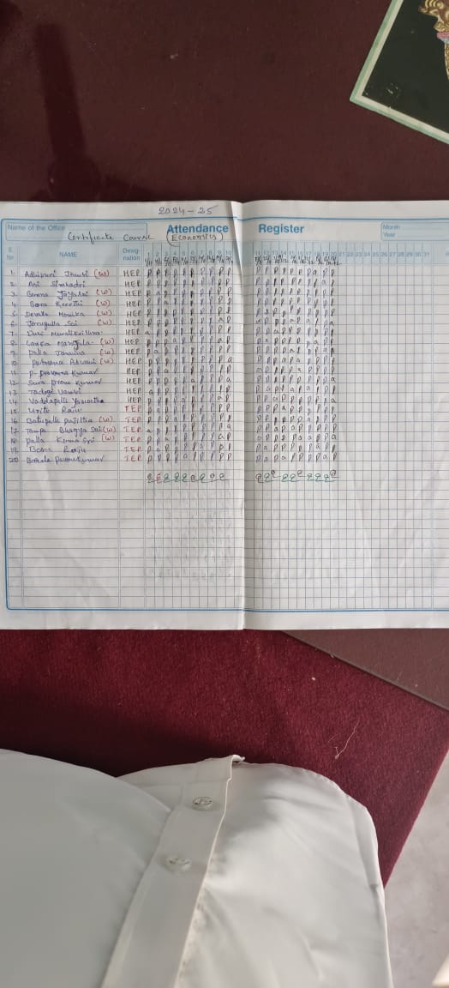

**CERTIFICATE COURSE ON TAX CONSULTANCY**

**Assessment**

**Academic Year2024-2025**

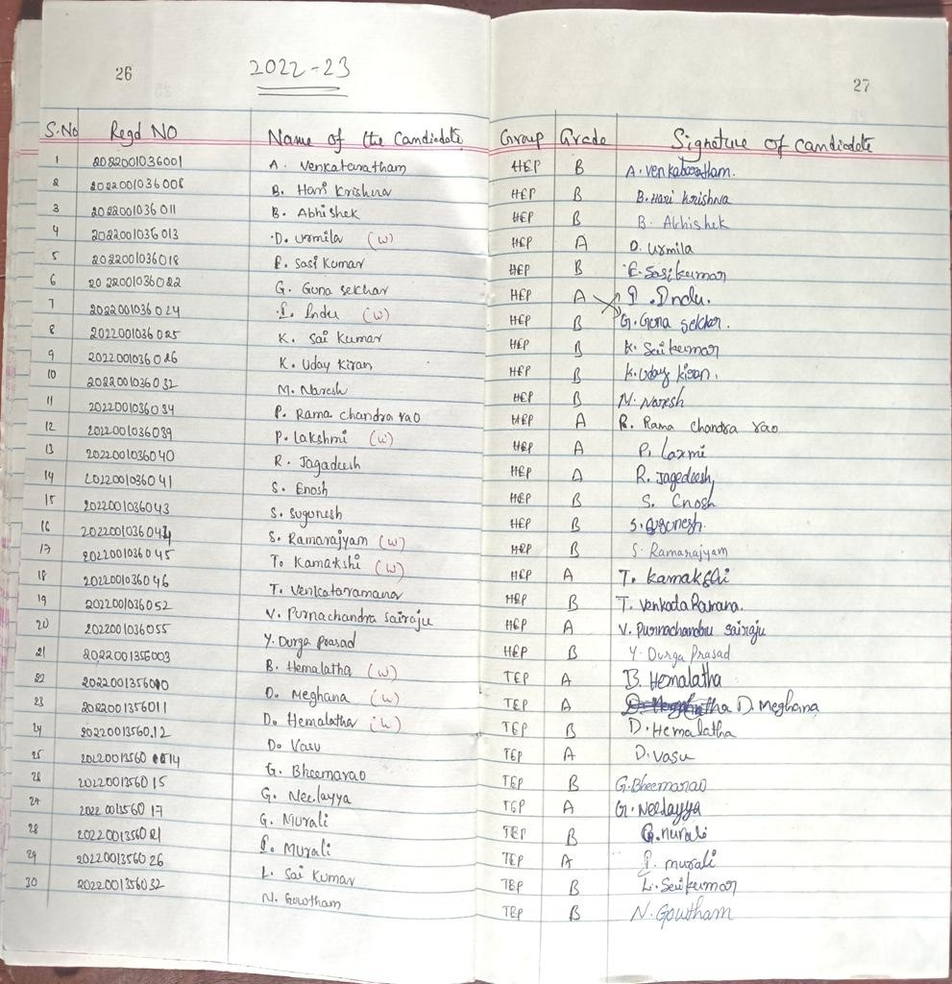

# Assessment:- 25Marks

TheAssessmentiscarriedoutbyconductinganExaminationfor25marksandthe Certificate will be awarded with Grades shown below.

21-25marks - “A”Grade

16-20marks - “B”Grade

11-15marks - “C”Grade

Lessthan11marksFail - “F”Grade

# WhatsApp Image 2022-07-18 at 12.55.09 PM.jpegWhatsApp Image 2022-07-18 at 12.55.09 PM (1).jpegGovernmentDegreeCollege(M), Srikakulam

**Feedback**

|  |  |
| --- | --- |
| Name of the event | Certificate Course On Tax Consultancy |
| Department | DepartmentOfEconomics |
| Date | *01-11-2024to17-12-2024* |
| Name of student | AlajangiVenkataRatnam |
| Class | B.A(HEP) |
| Mobile no. | 9392210419 |

1. Didtheeventfulfilit’sobjectives?
   * Yes/No
2. Howusefulwastheeventforyou?(0beingNotusefuland5Mostuseful)

|  |  |  |  |  |  |
| --- | --- | --- | --- | --- | --- |
| 0 | 1 | 2 | 3 | 4 | 5✓ |

1. Ratetheoverallsuccessoftheevent(0beingNotusefuland5Mostuseful)

|  |  |  |  |  |  |
| --- | --- | --- | --- | --- | --- |
| 0 | 1 | 2 | 3 | 4 | 5 ✓ |

1. **Listthekeytakeawaypointsfromtheevents.**

* Theeventhighlightedknowledgeofpreparationtaxation.

1. **Suggestionsifany**

* ISuggesttoorganizewithmoreCertificationCourses

SignatureoftheStudent

# WhatsApp Image 2022-07-18 at 12.55.09 PM (1).jpegWhatsApp Image 2022-07-18 at 12.55.09 PM.jpegRAMMURTY_SIR-removebg-preview.pngGovernment DegreeCollege(M),Srikakulam

## ConsolidatedFeedback

**Total no. of Participants=20**

**No.of participants from whom feedback is collected=15**

|  |  |  |  |  |  |  |
| --- | --- | --- | --- | --- | --- | --- |
| **S.No** |  | **No.of participants**  **graded“Yes”** | | **No.ofparticipantsgraded “No”** | | |
| **1** | Didtheevent fulfil it’s objectives | **15** | |  | | |
| **2** |  | **No. of participant sgraded-1** | **No. of participant sgraded –2** | **No. of participant sgraded-3** | **No. of participant sgraded-4** | **No. of participant sgraded-5** |
| **3** | How useful was theeventforyou |  |  |  |  | **15** |
| **4** | Rate the overall success of the event |  |  |  | **05** |  |
| **5** | key takeaway points from the event | 1. TheeventhighlightedthevariousopportunitiesTaxConsulatancy 2. UnderstandingthevariousTaxBenifits | | | | |
| **6** | Suggestions if  any | **1.**Moredaysofpracticehelpstogainmoreknowledge. | | | | |

**Coordinator**

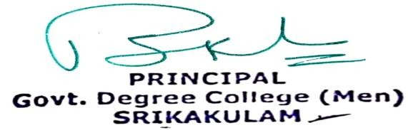

*******This is to certify that Mr.* ***A JHANSI*** *, student of Govt. Degree College (MEN), Srikakulam, Srikakulam District Studying* **BA (H.EP**)*has completed CERTIFICATE COURSE ON TAX CONSULTANCY Duration of 30 Hrs from 01-11-2024 to 17-12-2024 conducted by the Department of Economics in Govt. Degree College (Men) SrikakulamDistrictand Obtained Grade*  ***B***

**CourseCo-Ordinator IQACCoordinator Principal**